**Hawaii Annual Code Challenge 2018**

**Technical Review Guide**

**Wasteland**

|  |
| --- |
| **Challenge:** Waste Audit Data Collection  **Department / Organization:** UH Office of Sustainability |
| **Team Members:**   * Wendell Tashima * Allan Au * Andy Uehara * Pontus Jaeger * Volkan Buyukacar * Tyler Buyukacar * Nicole Buyukacar |

Contents

Technical Review Information 2

Challenge Information 2

Background 2

Technical Review Criteria 2

Technical Implementation 2

Quality of Solution 3

Innovation and Excellence 4

User Experience/Design 4

Salesforce Quick Start Information 7

Login Instructions for Wasteland Salesforce Application 8

Mobile Access 10

Using Mobile Salesforce Application 10

Using Simulated Mobile Application from a Web browser 11

Wasteland User Guide 13

Common Terminology 13

High Level Audit Work Flow 15

Application Menu 15

Organization Management 16

Audit Management 19

Reporting 24

# Technical Review Information

## Challenge Information

* **Challenge:** Waste Audit Data Collection
* **Department / Organization:** UH Office of Sustainability
* **Contact Information:** Nicole Chatterson, 808-561-7730, [nchatter@hawaii.edu](mailto:nchatter@hawaii.edu)

### Background

UH students have been leading a charge to update campus waste audits by helping track, monitor, and measure improvements in waste reduction. This information will be used to help make informed recommendations to administration on policy-to-practices interventions.

Audit recommendations would support waste reduction, green procurement procedures, zero waste planning, sustainable materials management and GHG emissions reductions.

Challenges:

* Capacity to collect basic data on campus waste streams is limited
* Data that is collected needs to be consistent
* Ability to expand this work to K-12 campuses, other government agencies, local business and community organizations

To be used by UH Buildings and Ground Management, Administration, Students, Faculty / Researchers

## Technical Review Criteria

### Technical Implementation

Waste Audit Data Collection challenge stated 3 specific areas to improve:

* Capacity to collect basic data on campus waste streams is limited
* Data that is collected needs to be consistent
* Ability to expand this work to K-12 campuses, other government agencies, local business and community organizations

Currently the ability collect basic waste audit data in a consistent way has challenges and limitations. This fact make compiling and reporting on this data slow and problematic. There is also a desire to expand waste audits to other campuses, government agencies, and even businesses and community organizations. However without an easy and fast way to collect and process the data, inviting other organizations to join waste auditing is not feasible.

As Wasteland Team we have tried to address these challenges on a working prototype. Our Salesforce application provides the following solutions:

* Ability to add new organizations, sites and buildings. This functionality will help expanding the waste audits to other organizations from a central application.
* Ability to create Audits.
* Ability to collect data from web and mobile interfaces.
* Aggregate and store data centrally for all participating organizations.
* Report and analyze data.
* Ability to create quick view dashboards.
* Track volunteer information

We have selected Salesforce as a platform, because

* Speaking to Salesforce representatives, we have learnt that Hawaii State had invested in Salesforce as a platform. Salesforce could be available as a platform if a decision made to use Wasteland application idea.
* Salesforce provides a platform to quickly prototype solutions and provides web and mobile versions. We had limited time to set aside for this project, and we wanted to deliver the best value with the minimum amount of coding.
* Salesforce allowed us to test feasibility of a data/object model quickly. We believe reaching to a solid data/object model is important, because a solid model can easily be ported to other platforms with use of standard object-mapping and model–view–controller frameworks.
* Salesforce is a new technology for our group members and we wanted to use our newly learnt skills.

### Quality of Solution

Using powerful Salesforce platform, we were able to deliver a working prototype of Wasteland application. The prototype as it is current state can be used to do following tasks.

#### Audit Management

You can use wasteland application to create audits. Each audit can have multiple related Building Audits. These Building Audits than can be assigned to volunteer groups for data entry.

Audit data can be immediately entered from the audit site using standard mobile Salesforce application on tablets and cell phones. As soon as the data are entered into the system, data become available to reports and dashboards. No additional data aggregation or work needed to be able to report on the data.

Because audit data are collected centrally, Wasteland application can report on the data using multiple dimensions; such as organizations, buildings, islands, sites, and over time. We have set up a series of reports already, but new reports and dashboards can be easily added by power users.

Application also allows tracking of audit volunteer information. This volunteer information can be used for follow ups and future audit planning. Even more so, because the application is built on Salesforce, functionality such as emailing volunteers directly from the application becomes available. Salesforce calendar, tasks, and contacts are other functionality that is available from the platform.

Audit data can be exported from reports to load to other repositories, such as relational databases or business intelligence tools.

#### Organization and Site Management

Current prototype allows addition of new organizations, sites, and buildings. With this functionality we can onboard new organizations who want to participate in waste audits.

Adding new organizations is as easy as adding them to the system. After a new organization is added to the system, their campuses can be defined as sites. Buildings then can be added to each site. Once all set up, new Building Audits can be created for these organizations and they can start entering their audit data.

#### Reports and Dashboards

Wasteland being a Salesforce application, all reporting and dashboards features of the platform are available to the users. We have set up some of the reports after studying the challenge documents and speaking to Nicole Chatterson. However power users can easily add new reports and dashboards as needed.

### Innovation and Excellence

Speaking to Salesforce representatives during the HACC kick off, we have learnt that Hawaii State has invested in Salesforce as a platform. As new platforms are introduced to organizations, there is always the challenge to encourage adoption.

We are hoping Wasteland waste audit application will demonstrate how functioning applications can be built in Salesforce quickly with minimal amount of coding and cost. Wasteland application could be one of the pioneer use cases for other departments to get encouraged to look into building solutions using Salesforce platform.

### User Experience/Design

We have used following resources for our requirements gathering:

* Presentations, materials from HACC kick off.
* Interviews and email exchanges between our group and Nicole Chatterson
* UHM 2017 Waste Audit_Final Report
* Conversation with Salesforce representatives during the HACC kick off

We have done daily one hour group meetings to discuss requirements, and design. Design implementation is done at night by individual contributors.

Our high level schedule was:

* **Week 1** 
  + Requirements gathering
  + Platform selection
  + Data model
  + Salesforce set up
  + Custom object creation
  + Early prototype, reports and dashboards
  + Prototype review with Nicole Chatterson.
* **Week 2** 
  + Revision of requirements from Nicole’s input
  + Revisions to data model, user interface
* **Week 3** 
  + Change freeze for documentation, video and presentation work
  + Document and presentation preparations

During the kick off event we have gathered some initial information to understand the waste audit process and requirements for a potential solution that addressed the challenges. First few days were spent discussing the waste audit process, and a selecting a development platform. We have also started to put together an initial data model. (Note: For our final custom object/data model, please refer to the “Object Model” section of this document.)

During the first week we have reached out to Nicole Chatterson with additional questions. With the amount of information we gathered, we were able to decide on an initial data model and set up custom Salesforce objects, reports and dashboard.

During the first Workshop at the end of first week, we had a chance to present our early prototype to Nicole Chatterson. After reviewing the early prototype, Nicole provided us with additional requirements and guidance.

* Add a note field on bag screen so people could provide notes for each bag.
* Instead of allowing users to enter a specific percentage, provide them with ranges. The midpoint of the range would be used for volume calculations.
* Nicole showed us a spreadsheet where she manually tracks volunteers. She mentioned that as a coordinator same organizations and people are recruited for waste audit. Because analysis of data needs some scientific rigor they wanted people they trusted and were interested to sorting and recording to do audit. Not just post a sign up on web for anyone to sign up.

During our second week, following Nicole’s new requirements and input, we made changes to our design.

* Modified Bag object to have a note field.
* Changed bag fullness percentage fields to percentage ranges. For example instead of %25 or 50% full, a range of options as %25 to %49 and %50 to %74. This was done after Nicole confirmed the ranges and midpoint calculation on Slack.
* Changed the volume calculation on bag object to calculate volume to use Bag size selected multiplied by the midpoint of the range selected on percentage filled.
* Created new junction (building audit volunteer) object to tie contacts to building audit object. This would allow Audit Coordinator to track which volunteers worked at each building audit.
* Created the report and dashboard of volunteers. This mimics Nicole’s spreadsheet. Report can be filtered by date for each audit or upcoming audit.
* Modified page layout of the building audit volunteer form. It was a little cumbersome at first.
* Had to change page layout on bag object to allow for User to have easier time entering the data. The UI was even harder to work with for entering bag data before we modified the page layout.

At the end of our second week we placed a change freeze to focus on documentation, presentation, and any video materials.

#### Object Model

We have mainly used custom objects to store Wasteland application data. The only standard Salesforce object we used is Contacts object to store volunteer information. Following are the list of custom objects:

* Audit
* Bag
* Building
* Building Audit
* Building Audit Contact
* Organization
* Site

Below is a screenshot of object model diagram:

[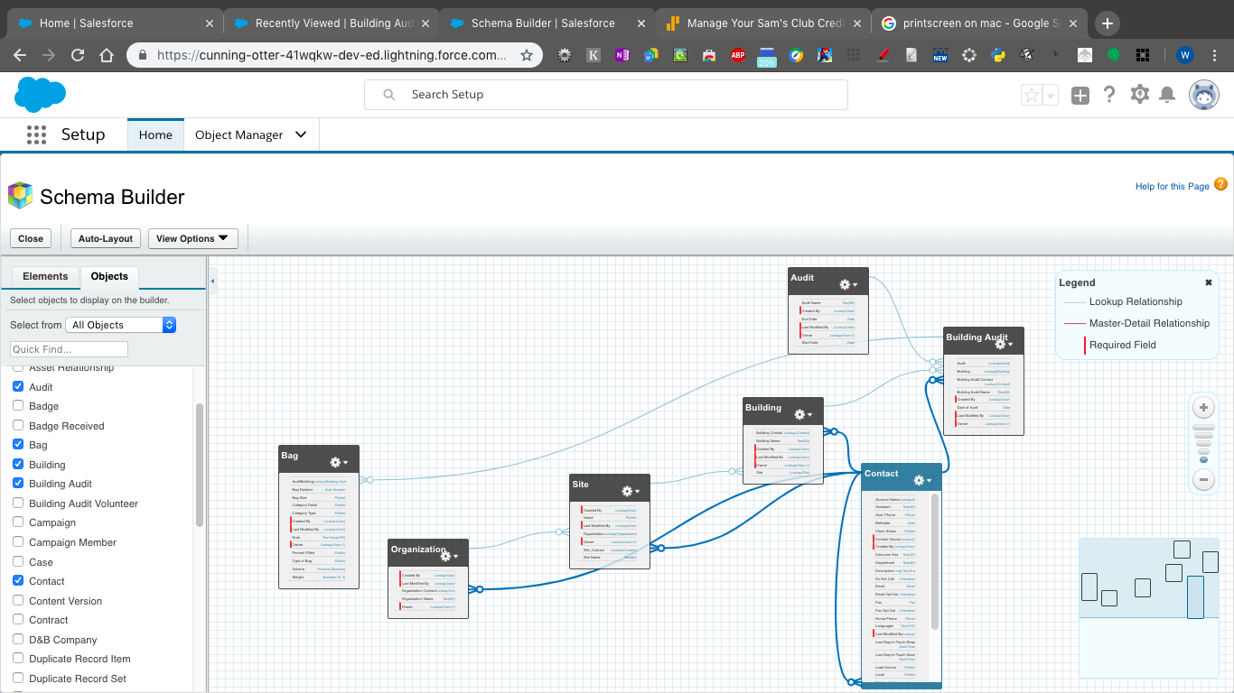](https://github.com/HACC2018/Wasteland/blob/master/Object%20Diagram.png)

You can find Custom Object details such as field definitions in “[CustomObject.xls](https://github.com/HACC2018/Wasteland/blob/master/CustomObject.xls)” in Github.

You can also access custom object definitions and schema diagram from Salesforce by following the instructions below.

1. Login to Salesforce.
2. If you are not in “Set up” screen, go to set up:

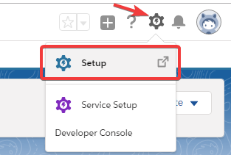

1. From set up click on “Object Manager”. In Object Manager you can access the object details.

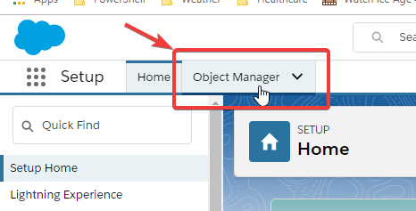

1. From Object Manager screen, click on “Schema Builder” for visual object diagram

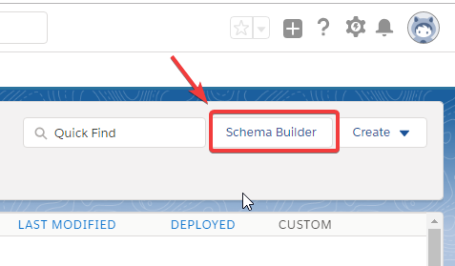

# Salesforce Quick Start Information

Instructions for accessing Wasteland Salesforce application is provided below.

**Salesforce User Information** (In order to logon to Salesforce Trailhead Org)

* **Username:** wastelandhacc@yahoo.com
* **Password:** (We sent password to jason@sudokrew.com)
* **URL for login:** [www.salesforce.com](http://www.salesforce.com)

**Yahoo User Account** (For verification code sent for first time salesforce login)

* **Username:** wastelandhacc@yahoo.com
* **Password:** (We sent password to jason@sudokrew.com)
* **URL for login:** <login.yahoo.com>

## Login Instructions for Wasteland Salesforce Application

**Step 1:** In a browser navigate to [www.salesforce.com](http://www.salesforce.com) website

**Step 2:** Click on “Login” link on the top right

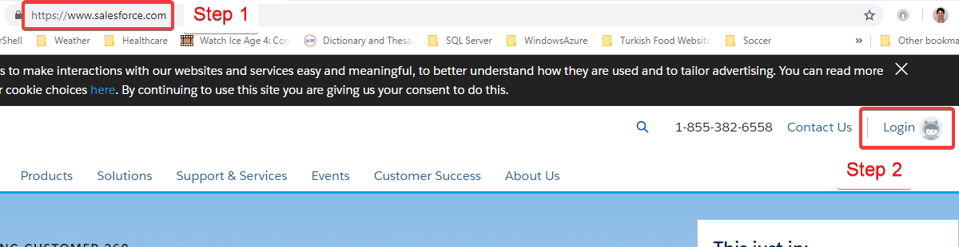

**Step 3:** Enter salesforce username and password and click on login link.

* **Username:** wastelandhacc@yahoo.com
* **Password:** (We sent password to jason@sudokrew.com)

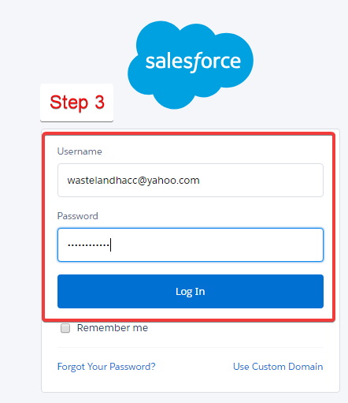

**Step 4:** If a verification code is asked, logon to yahoo mail at login.yahoo.com using the following account to receive the verification code.

* **Username:** wastelandhacc@yahoo.com
* **Password:** (We sent password to jason@sudokrew.com)

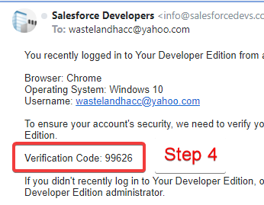

**Step 5:** Enter verification code and click verify. This will land you to Salesforce Setup home page.

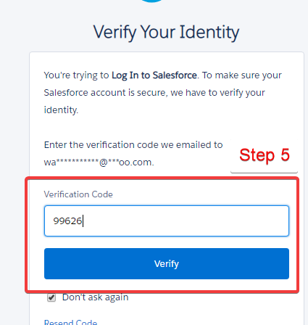

**Step 6:** If landed on setup home page click “App Launcher” link.

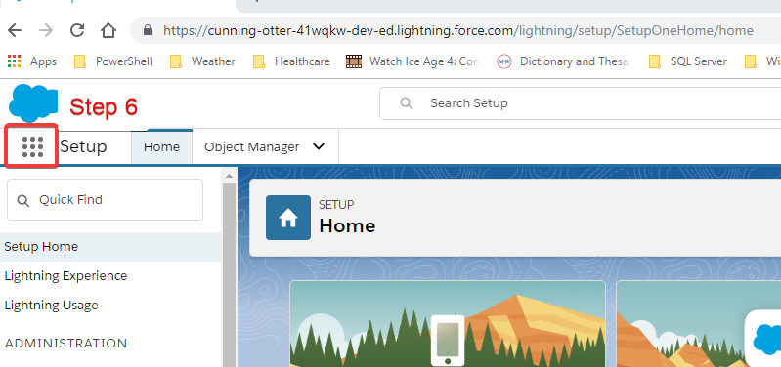

**Step 7:** From App Launcher list select “Wasteland” application.

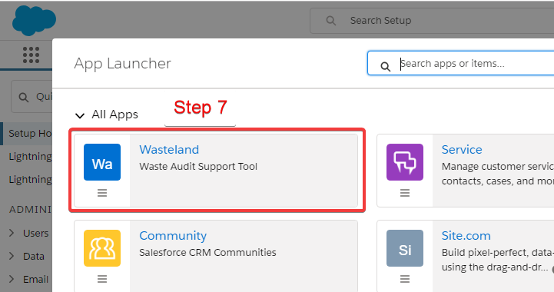

**Step 8:** You are now in Wasteland Salesforce app and should see screen below.

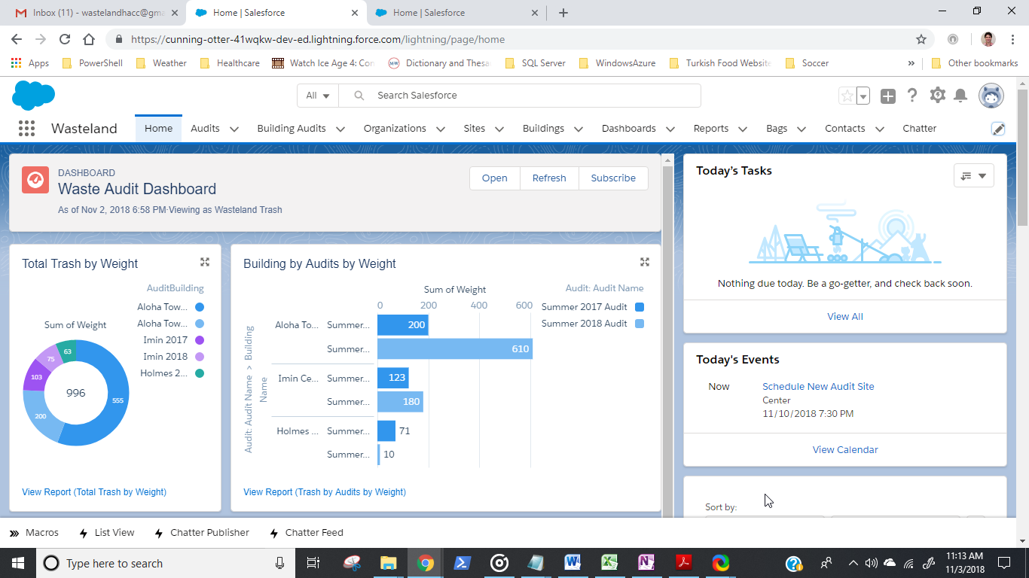

## 

## Mobile Access

### Using Mobile Salesforce Application

Mobile access to Wasteland Salesforce application is done through the standard Salesforce mobile application. In order to access Wasteland Salesforce application from a mobile device, download and install Android or IOS version of Salesforce application, then login with the user account provided below.

<https://www.salesforce.com/solutions/mobile/app/>

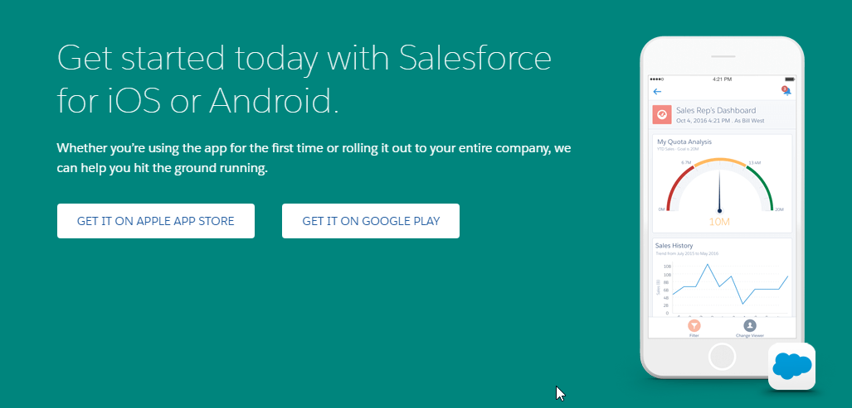

Use the following user account to logon to the mobile application.

**Salesforce User Information** (In order to logon to Salesforce Trailhead Org)

* **Username:** wastelandhacc@yahoo.com
* **Password:** (We sent password to jason@sudokrew.com)

At first login you may be asked for a verification code. If a verification code is asked, use following Yahoo account to obtain the passcode from Yahoo mail.

**Yahoo User Account** (For verification code sent for first time salesforce login)

* **Username:** wastelandhacc@yahoo.com
* **Password:** (We sent password to jason@sudokrew.com)
* **URL for login:** <login.yahoo.com>

### 

### Using Simulated Mobile Application from a Web browser

**Step 1 –** Log on to Salesforce using a browser. Once in Wasteland application copy the URL:

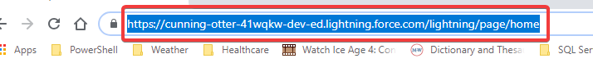

**Step 2 –** Open a new browser window and Hit **“F12”** function key to open developer tools interface.

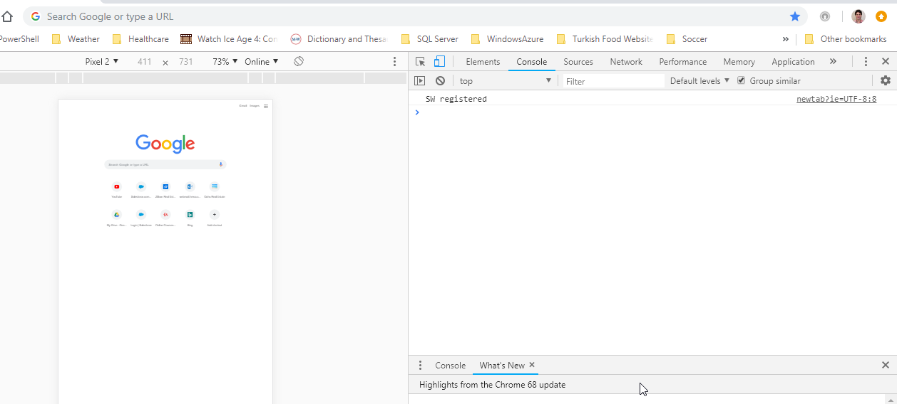

**Step 3 –** Copy the URL from Step 1

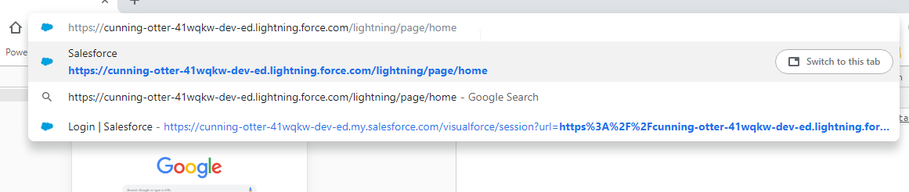

**Step 4 –** Select a device to simulate.

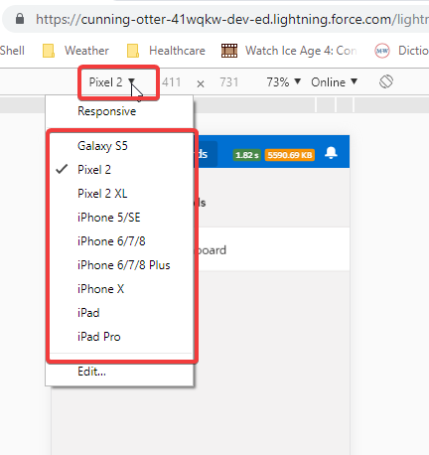

**Step 5 –** Explore the mobile app

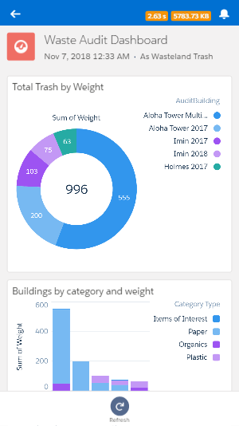

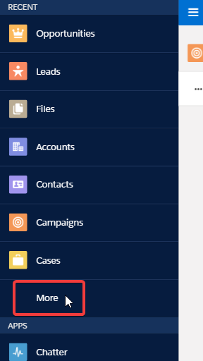

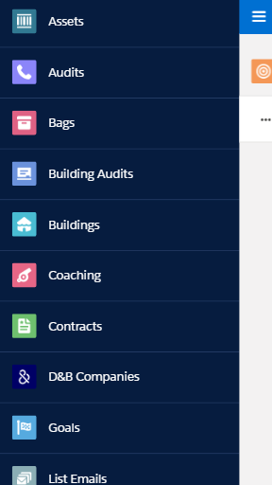

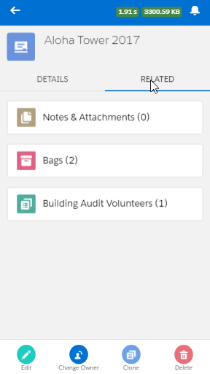

# Wasteland User Guide

## Terminology

**Organization:** An organization in Wasteland application is an independent entity participating in waste audits. This entity could be a collage such as University of Hawaii (UH), a K-12 school such as Aiea High School, a state department, or even a local business wanting to participate in waste audits.

**Site:** A site is a geographically distinct location of an organization. For example Manoa campus could be a UH site. Organizations are free to define their sites. For example if UH wanted to split Manoa campus into multiple sites for reporting purposes, they could do so. Each organization must have at least one site.

**Building:** Buildings are locations of interest where we want to audit the waste. It could be a building literally, or a location where dumpsters are placed. Each site must have at least one building defined.

**Audit:** Audits are parent events where building audits are grouped under. For example if periodic audits are planned yearly an audit should be created for each event. Each audit can have one or more building audits related to it.

**Building Audit:** Building audits are the data collection points for waste audits. Building audits are created as part of a parent audit event.

**Bags:** Bags are unit of data collection. Each bag has a weight and volume measurement of a select waste category. Each building audit can have one or more bags.

## High Level Audit Work Flow

**Step 1 – Set up an organization** (See “Organization Management” section of this document)

* Add new organization
* Add sites to new organization
* Add buildings to sites

**Step 2 – Set up an Audit (**See “Audit Management” section of this document)

* Add a new audit
* Add building audits to the new audit
* Add volunteer information to building audits

**Step 3 – Waste audit and data collection** (See “Audit Management” section of this document)

* Add bags (waste category measurements) to building audits

**Step 4 – Report and analysis** (See “Reporting” section of this document)

* Use built in reports and dashboards to analyze data
* Create new reports
* Export data

## 

## Application Menu

Application menu has 3 main functional groupings.

* Audit Management
* Organization Management
* Reporting



**Audit Management:** Using these menu items we can add/edit audit events, building audits, and add measurements to the building audits as bags.

**Organizational Management:** These menu items can be used to add/edit organizations, sites, and buildings.

**Reporting:** Reporting section has a list of dashboards, and reports. Power users can use this section to add new reports and dashboards. Data can be exported to from this section as well from reports.

### Organization Management

Work flow “**Step 1 - Set up an organization**” tasks can be done using the organization management menu items.

**Work Flow Step 1 – Set up an organization**

* Add new organization
* Add sites to new organization
* Add buildings to sites

#### Organizations Menu

Using “Organizations” menu we can view existing organizations, edit existing organizations, and add new ones.

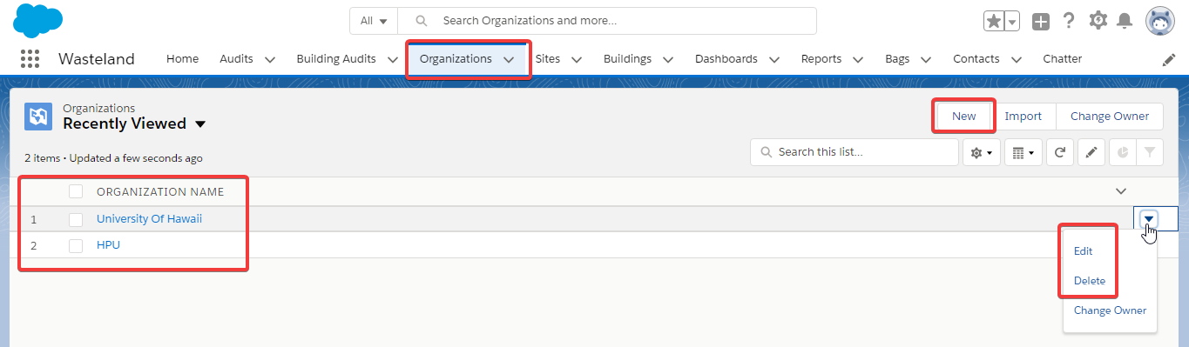

We can review the details of an organization by clicking on them from the list.

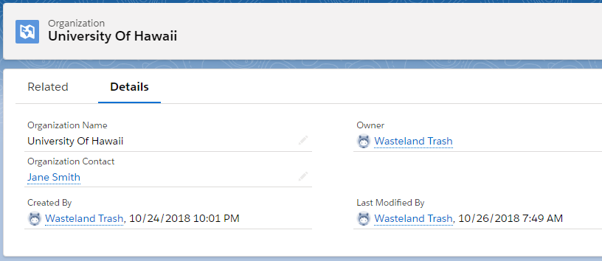

We can view sites that belong to an organization from the “Related” section. We can also add, edit or remove sites.

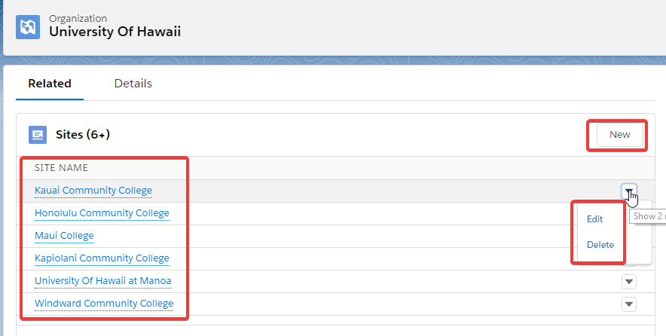

#### Sites Menu

Using “Sites” menu we can review and edit existing sites, and add new sites.

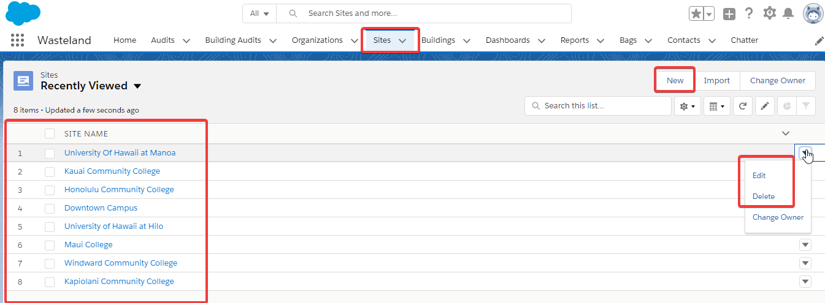

We can click on sites in the list to review the details.

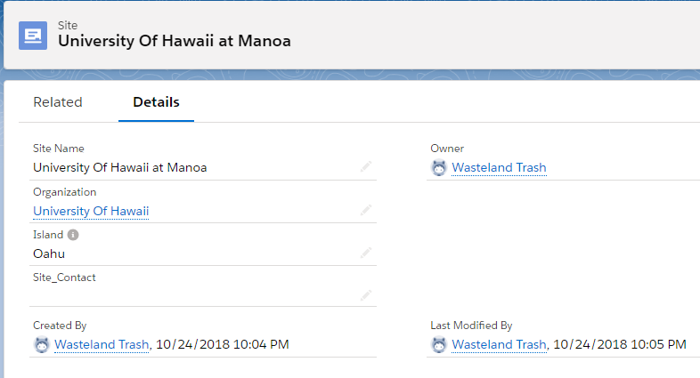

We can view related buildings for each site using the “Related” section. We can add, edit, or remove buildings from this area.

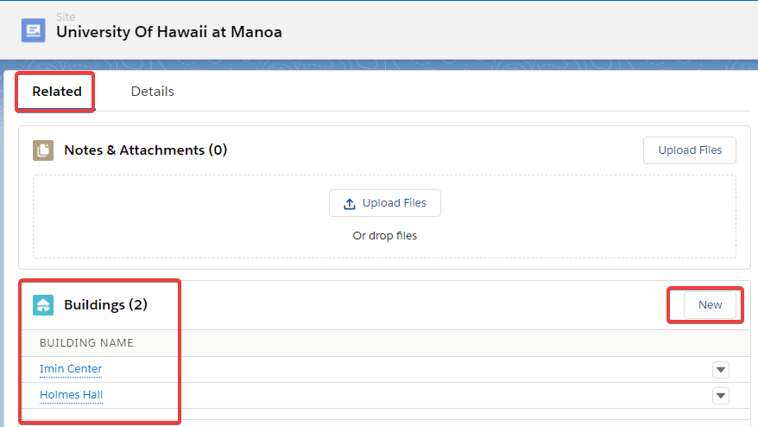

#### Buildings Menu

We can review and edit existing building records from “Buildings” menu and add new buildings.

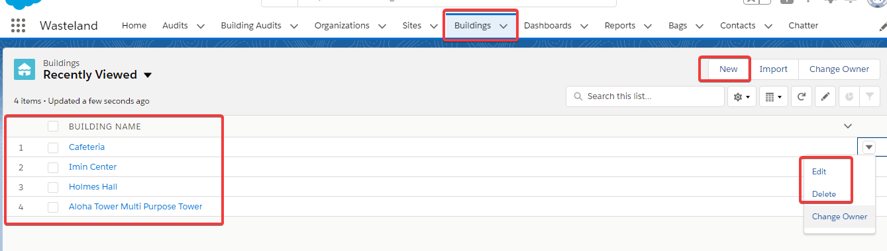

We can view details of each building by clicking on them.

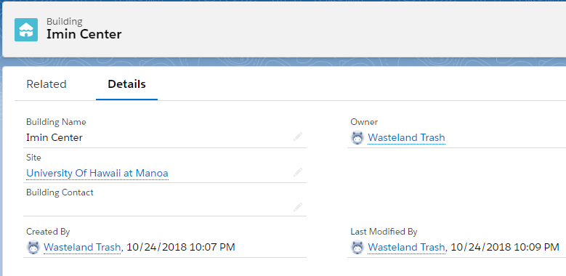

We can also use the “Related” section to view, or add new building audits.

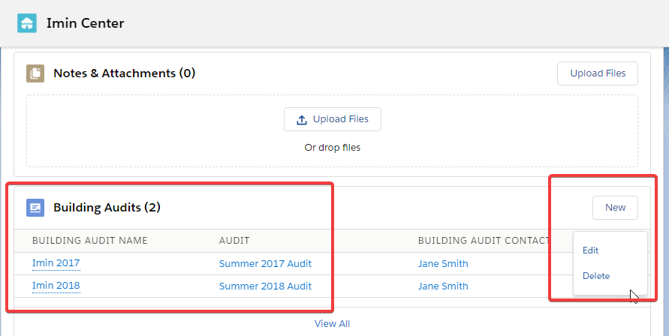

### Audit Management

Work flow “**Step 2 – Set up an Audit”** and **“Step 3 – Waste audit and data collection**” tasks can be done by using audit management menu options.

**Work Flow Step 2 – Set up an Audit**

* Add a new audit
* Add building audits to the new audit
* Add volunteer information to building audits

**Work Flow Step 3 – Waste audit and data collection**

* Add bags (waste category measurements) to building audits

#### Audits Menu

Using “Audits” menu we can view, edit, add, and remove audits.

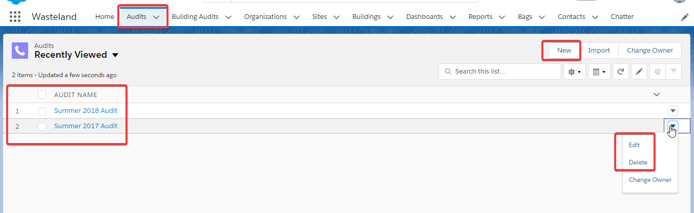

We can view the details of each audit.

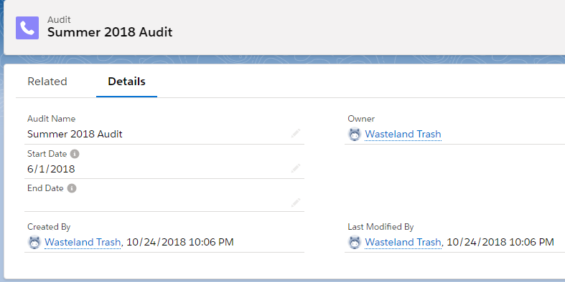

And view, add, edit, and remove related building audits from “Related” section.

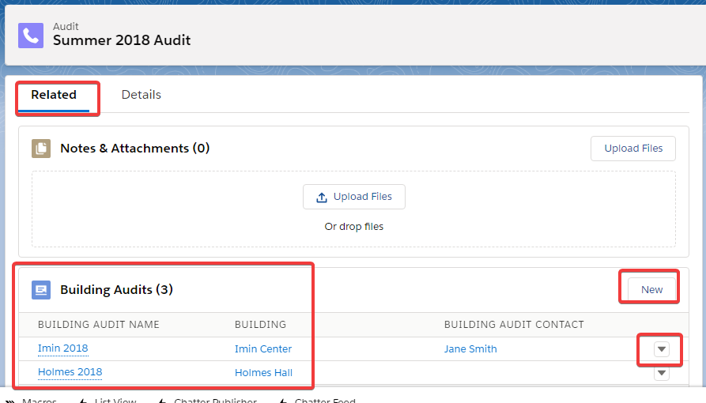

#### Building Audits Menu

Using this menu we can view list of existing building audits, or add, edit, and remove building audits.

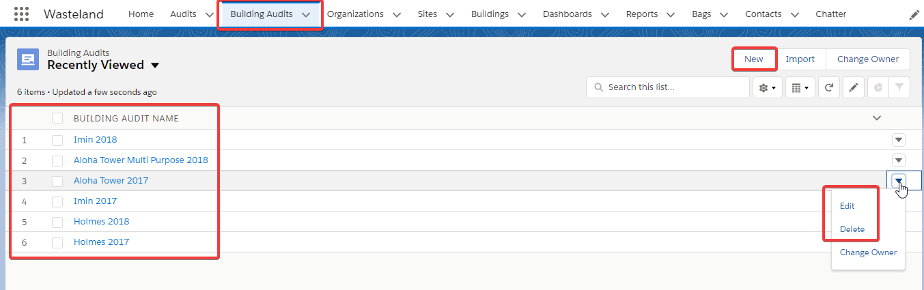

View the detail of each building audit.

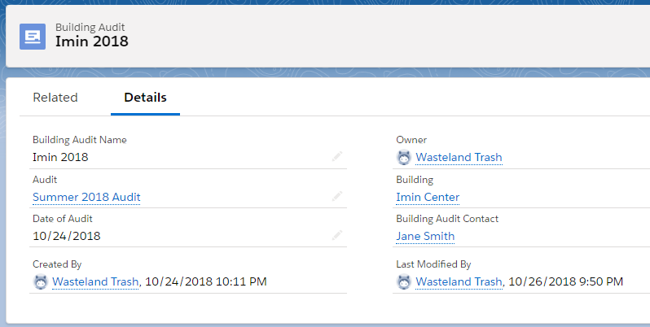

Or access and enter bag information to each building audit from “Related” section. This menu can be used by volunteers to enter bags to each building audit.

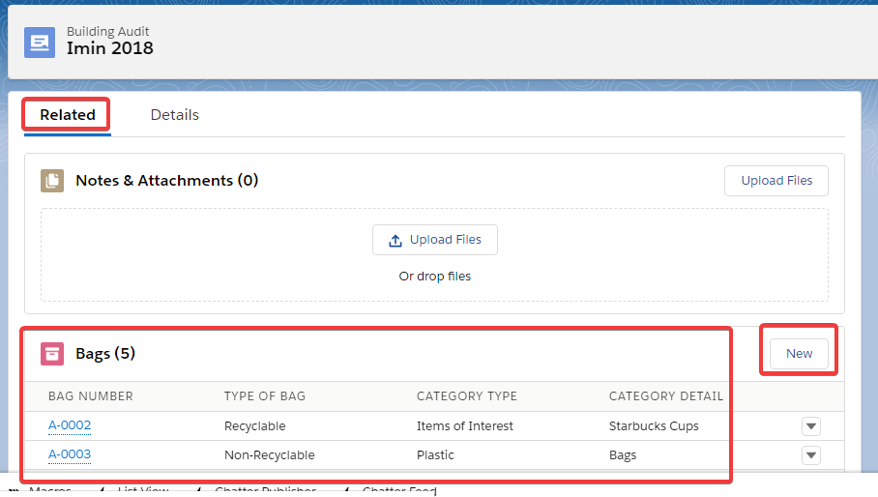

#### Bags Menu

Even though “Bags” menu is not grouped together with audit and building audit menu, they are related. Bags menu can be used to enter waste audit measurements.

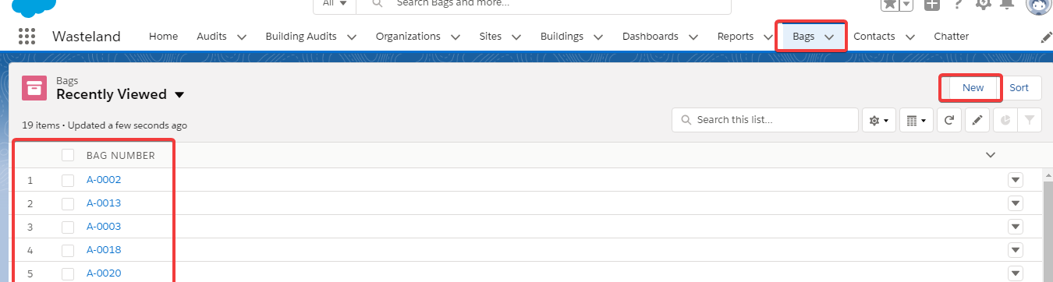

Bags are the unit of measure for each waste category. We can view the details of each bag by clicking on them.

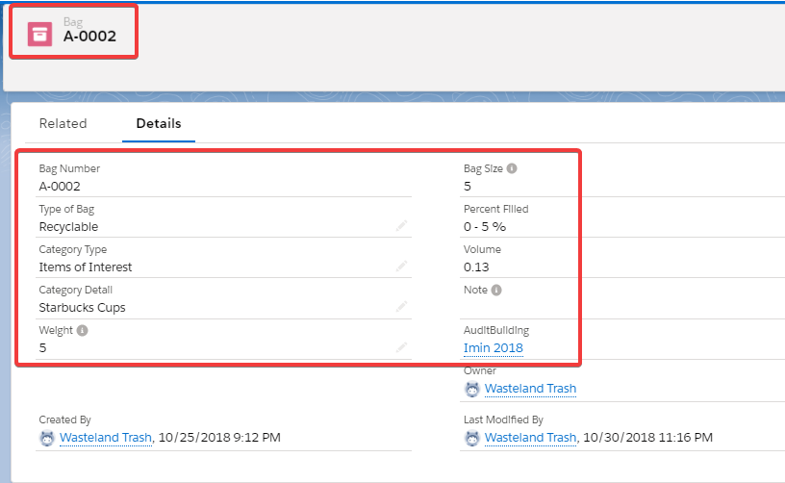

We can enter new bags to a building audit.

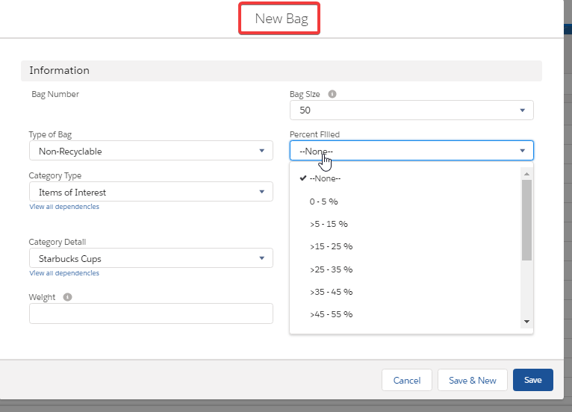

And add notes.

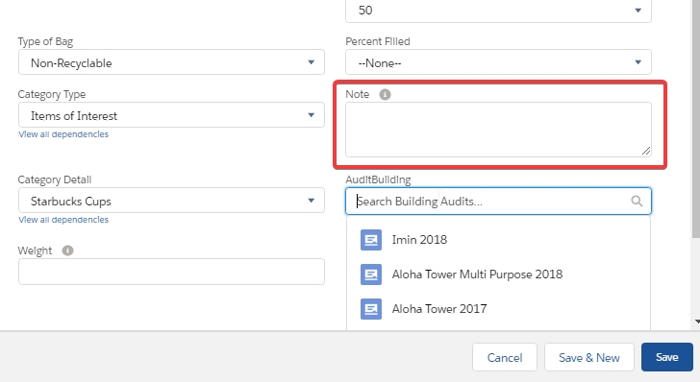

### 

### Reporting

#### Reports Menu

Reporting menu provides a list of built in reports, and tools for power users to create new reports.

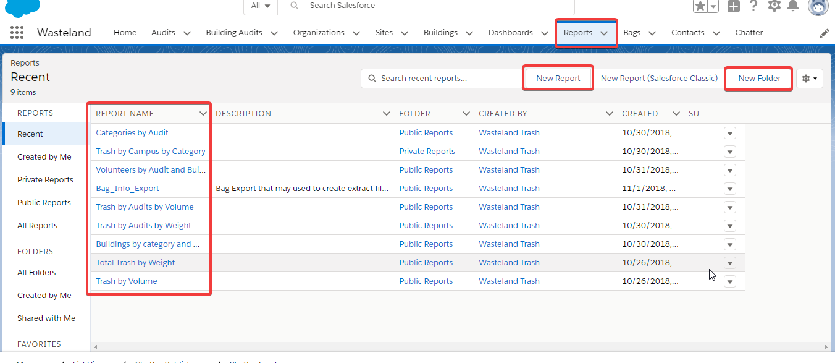

#### Dashboards Menu

Dashboards provide an area to aggregate report summaries for quick view of waste audit data. Power users can also add new dashboards.

